**A Grocery Shopping List in Python**

**By**

**Angela Marks**

**Introduction**

I will create a Grocery Shopping List using Python and a list data structure. We can do three tasks with this grocery shopping list: adding the grocery list into the program, removing a grocery list from the program once the shopping is completed, and displaying the whole grocery list in order. The user must interact with the Grocery Shopping List throughout the program since the data must be continuously input and output. Each time the user inputs data, the program displays the result, whether it is added, deleted, or displayed.

**Creating Scenario**

**Scenario 1:** The user inputs the data into the Grocery Shopping List.

1. The Grocery Shopping List program greets the user by prompting them that it is ready to be started.

2. Displays choices on the screen for the user to choose:

A is for Adding Grocery List

B is for Removing Grocery List

D is for Displaying Grocery List

3. The user chose A.

4. The program asks the user to input the data.

5. The user inputs the data into the grocery list.

6. The program output, “The grocery list was added successfully.”

7. The program returns to the beginning.

**Scenario 2:** The user removes the data from the Grocery Shopping List.

1. The Grocery Shopping List program greets the user by prompting them that it is ready to be started.

2. Displays choices on the screen for the user to choose:

A is for Adding Grocery List

B is for Removing Grocery List

D is for Displaying Grocery List

3. The user chose R.

4. The user asks the user to input the data they want to remove.

5. The user inputs the data they want to remove into the grocery list.

6. The program outputs, “Grocery list removed successfully.”

7. The program returns to the beginning.

**Scenario 3:** The user removes the non-existent data from the Grocery Shopping List.

1. The Grocery Shopping List program greets the user by prompting them that it is ready to be started.

2. Displays choices on the screen for the user to choose:

A is for Adding Grocery List

B is for Removing Grocery List

D is for Displaying Grocery List

3. The user chose R.

4. The user asks the user to input the data they want to remove.

5. The user inputs the data they want to remove into the grocery list.

6. The program outputs, “Grocery list not found.”

7. The program returns to the beginning.

**Scenario 4:** The user wants the program to display the grocery list.

1. The Grocery Shopping List program greets the user by prompting them that it is ready to be started.

2. Displays choices on the screen for the user to choose:

A is for Adding Grocery List

B is for Removing Grocery List

D is for Displaying Grocery List

3. The user chose D.

4. The program outputs the grocery list in order.

5. The program returns to the beginning.

**Scenario 5:** The user wants the program to display a non-existent grocery list.

1. The Grocery Shopping List program greets the user by prompting them that it is ready to be started.

2. Displays choices on the screen for the user to choose:

A is for Adding Grocery List

B is for Removing Grocery List

D is for Displaying Grocery List

3. The user chose D.

4. The program outputs, “The grocery list is empty.”

5. Theprogram returns to the beginning.

**Pseudocode**

#Intitialiaze an empty list to store grocery lists

groceryLists = []

#Adding the grocery list into the program

Add grocery list into the program

Print output to confirm that the grocery list is added successfully.

#Removing the grocery list out of the program

if there is a grocery list inside a grocery list

print that the grocery removed successfully

else

Print the grocery list not found

#Displaying the grocery list

if there is a grocery list inside the grocery lists

Print the grocery list in order

else print that the grocery list is empty

#Adding the grocery list into the program

The program is getting the grocery list from the user

Return the input in “Enter the grocery list:” to the user

#Removing the grocery list out of the program

The program is removing the grocery list from the user

Return the input “Enter the grocery list to remove:” to the user

#Displaying grocery list

The program is displaying the grocery choices for the user to choose

Return the input where the user enters ‘A’ to add a grocery list, ‘B’ to remove a grocery list, ‘D’ to display the grocery list

#Create the loop to run the program

While True

Print the output, “Hello! Welcome to Grocery Shopping List.”

Getting the choices from the grocery list choices

if the user choses choice ‘A’

Add the grocery list into the grocery list variable

elif the user choses choice ‘R’

Remove the grocery list from the grocery list variable

elif the user choses choice ‘D’

Display the grocery list from the grocery lists variable

Else

Printing it’s an invalid choice. Ask the user to try again.

**Testing**

Since this is a simple program, my main mistakes were spelling, typos, indentation, and choosing the wrong wording for variables. When I first started the coding part. When I completed the function about adding, removing, and displaying the grocery items, I tested if they worked by calling those functions as described below:

#Testing to see if the function works

Add_groceryList(“milk”)

Display_groceryLists()

Remove_groceryList(“milk”)

Display_groceryLists()

The program displayed an error, and I was confused about what was happening. I tried to fix it several times until I discovered I had put the quotation mark in the wrong position.

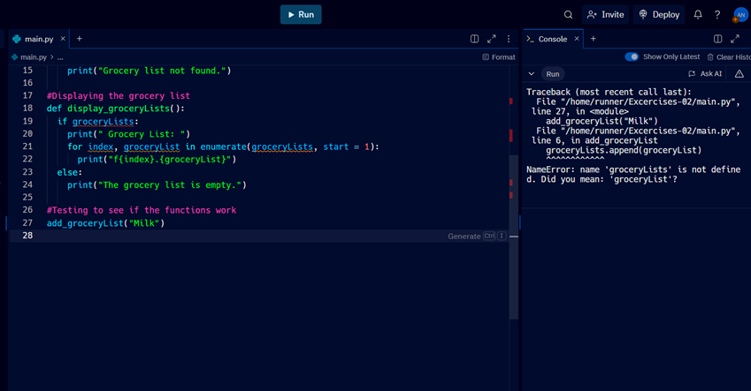

As seen in the picture, in line 22, I typed print(‘f{index}.{groceryList}’) instead of print(f{index}.{groceryList}). Once I fixed the code, it worked properly. The next one I tried to work out was about looping. It seems to be indefinite. I want the loop to stop at some point, so it doesn’t keep running forever. So, I changed the code by inserting the “Q” option to quit. If the user chooses “Q,” the loops go straight to the “Break” and ultimately stop.

while True:

print("Hello!\n"

"Welcome to Grocery Shopping List.")

choice = get_groceryList_choice()

if choice == 'A':

groceryList = get_groceryList_from_user()

add_groceryList(groceryList)

elif choice == 'R':

groceryList = get_groceryList_to_remove()

remove_groceryList(groceryList)

elif choice == 'D':

display_groceryLists()

else:

print("Invalid choice. Please try again. ")

Here is how the code looks with the “Q” for the “Quit” option.

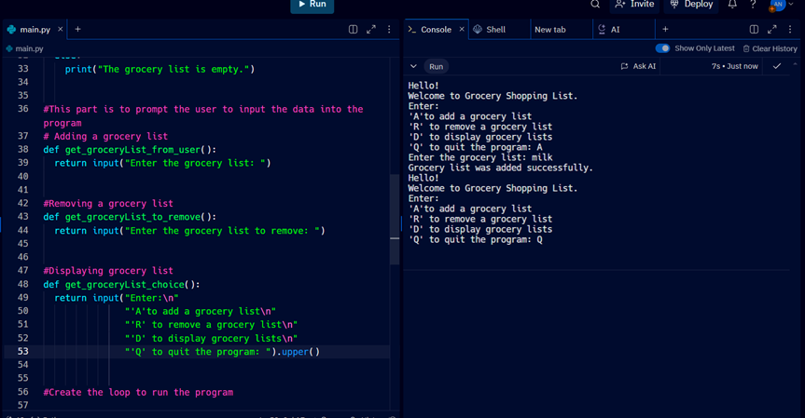

Lastly, I reread all the code and tested it to see if it worked. It does work fine, but I feel like the wording is quite confusing. Since I used “GroceryLists,” this program has only one grocery list. So, I changed it to “GroceryList” instead of “GroceryLists.” I also changed “GroceryList” to “groceryItem.” Moreover, I did change the word “choice” to “option” for better understanding.

**Example 1:**

#Create a list of strings to keep track of the gorcery shopping list

groceryLists = []

#Adding grocery list

def add_groceryList(groceryList):

groceryLists.append(groceryList)

print("Grocery list was added successfully.")

**Example 2:**

while True:

print("Hello!\n"

"Welcome to Grocery Shopping List.")

choice = get_groceryList_choice()

if choice == 'A':

groceryList = get_groceryList_from_user()

add_groceryList(groceryList)

elif choice == 'R':

groceryList = get_groceryList_to_remove()

remove_groceryList(groceryList)

elif choice == 'D':

display_groceryLists()

elif choice == 'Q':

break

else:

print("Invalid choice. Please try again. ")

I changed the wording of the variables to make them clearer and easier to understand, as shown in pictures 1 and 2.

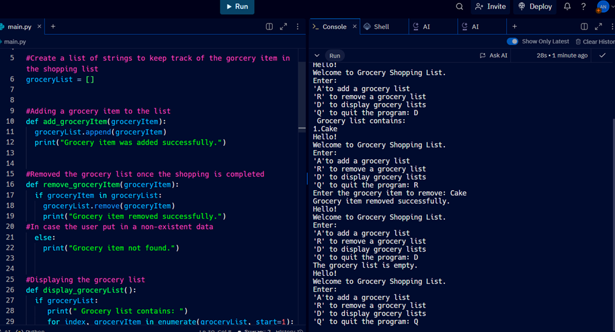**Picture 1:**

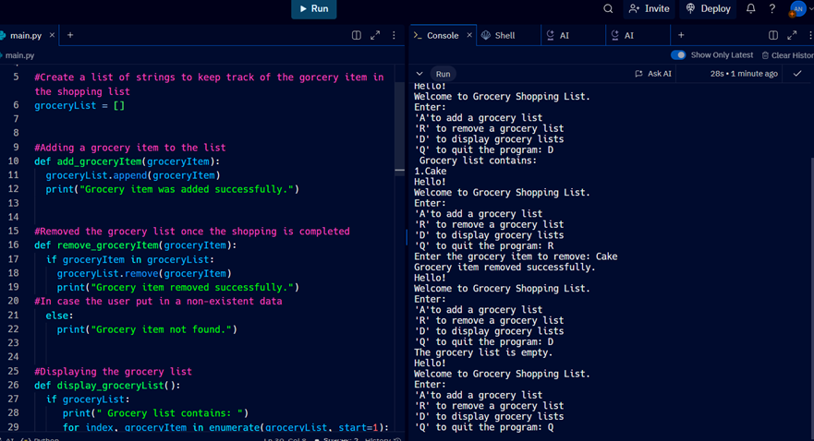**Picture 2:**

**Programming**

#This is a Grocery Shopping List

#It is created by using Python and a List as a data structure

#There are four options for the user to choose from in the #program: add, remove, display, and quit

#Create a list of strings to keep track of the grocery item in #the shopping list

groceryList = []

#Adding a grocery item to the list

def add_groceryItem(groceryItem):

groceryList.append(groceryItem)

print("Grocery item was added successfully.")

#Removed the grocery list once the shopping is completed

def remove_groceryItem(groceryItem):

if groceryItem in groceryList:

groceryList.remove(groceryItem)

print("Grocery item removed successfully.")

#In case the user put in a non-existent data

else:

print("Grocery item not found.")

#Displaying the grocery item in the list in order

def display_groceryList():

if groceryList:

print(" Grocery list contains: ")

for index, groceryItem in enumerate(groceryList, start=1):

print(f"{index}.{groceryItem}")

#In case the user put in a non-existen data

else:

print("The grocery list is empty.")

#This part is to prompt the user to input the data into the program

# Adding a grocery item to the list

def get_groceryItem_from_user():

return input("Enter the grocery item: ")

#Removing an item from the grocery list

def get_groceryItem_to_remove():

return input("Enter the grocery item to remove: ")

#Displaying the options for the user to choose what they want #to do

#There are four options to choose

#'A' is for adding a grocery item to the list

#'R' is for removing a grocery item from the list

#'D' is for displaying a grocery item in order

#'Q' is for quitting the program

def get_groceryItem_choice():

return input("Enter:\n"

"'A'to add a grocery list\n"

"'R' to remove a grocery list\n"

"'D' to display grocery lists\n"

"'Q' to quit the program: ").upper()

#Create the loop to run the program

while True:

print("Hello!\n"

"Welcome to Grocery Shopping List.")

option = get_groceryItem_choice()

if option == 'A':

groceryItem = get_groceryItem_from_user()

add_groceryItem(groceryItem)

elif option == 'R':

groceryItem = get_groceryItem_to_remove()

remove_groceryItem(groceryItem)

elif option == 'D':

display_groceryList()

elif option == 'Q':

break

else:

print("Invalid choice. Please try again. ")

**Completed Program**

<https://replit.com/join/sfesvfanif-angelamarks9>